Project Proposal

M.Sc Degree in Computer Science

Hadassah Academic College

Title: Frequency-dependent attenuation in fractional Helmholtz wave equations

Contents

Project Proposal 1

M.Sc Degree in Computer Science 1

Hadassah Academic College 1

Title: Frequency-dependent attenuation in fractional Helmholtz wave equations 1

1. Personal Details 2

2. Project Details 2

2.1. Project description 2

2.2. Project goals 5

2.3. Specifications and requirements 5

2.4. Background and relevant branches of computer science 6

2.5. Project complexity 6

2.6. Technology that will be used 7

2.7. Evaluation: How the success of the project will be measured? 7

2.8. Bibliography 7

3. Estimated Schedule 8

3.1. Gantt 8

3.2. Details 8

4. Approval 9

# Personal Details

Name of the student: Samuel Rouah-Sayag (שמואל רוח-סייג)

Address: 35, Eliezer Kashani, Jerusalem, 9380631, ISRAEL.

(אליעזר קשאני 35/10 9380631 ירושלים)

Telephone: 058-6275701

E-mail: samuelsayag@gmail.com

# Project Details

Project Advisor: Michael Berman

Project Name: Frequency-dependent attenuation in fractional Helmholtz wave equations

Location: Hadassah Academic College

## Project description

“By beaming high-frequency sound waves into the body, physicians can translate the "echoes" that bounce off body tissues and organs into "sound you can see," colorful, visual images that provide valuable medical information”[1]. The technique is very cheap (compared to other techniques such as CT (Computed Tomography), MRI (Magnetic Resonance Imaging), not harmful at all (fetal imaging), gives results in real-time (surgery) and is also extremely portable (moving ultrasound installation to the patient’s place is possible).

In standard (B-mode) ultrasound the image is created thanks to the information contained in the back-reflected waves (from the body organs). The acoustic stack is emitting and receiving only back-reflected sound waves. Images are constructed on the basis of the assumption of an average *speed of sound* and average *attenuation* that are independent of the location in the anatomy.

The following picture[2] of Figure 1 shows detected masses for given sound speed and attenuation and a biopsy (sample of cells) revealed the nature of the detected mass. From this graph it is obvious that the above two parameters (speed of sound and attenuation) deserve to be measured in order to gain further important information, such as characterizing tissue and segregating malignant tumors from benign ones. As mentioned above, this information is simply not available with B-mode ultrasound devices, and that is the main motivation for using ultrasound tomography. In tomography the anatomy is surrounded with transducers, and waves that pass through it are measured, providing enough information for reconstructing speed of sound and attenuation.

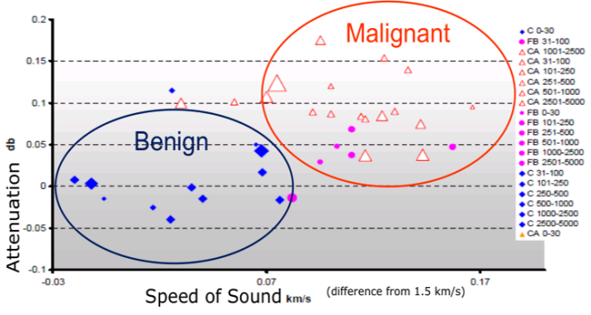

Figure 1: Detection and characterization of breast masses as a function of attenuation and speed of sound

Beside this, there is always the desire to increase resolution on the one hand and to access deeper organs on the other hand. The latter is limited due to attenuation. Indeed, better resolution may be obtained with high frequency, but attenuation also increases with higher frequencies and prevent the signal from reaching deeper in the tissue. In order to better understand this trade-off, a model is required that takes into account the speed of sound as a function of the space (2d or 3d) and the attenuation as a function of the space, as well as a function of the frequency.

The experiments show that attenuation follows a power low with an exponent in the interval of 1 to 1.5 that may be formulated the following way [1]:

|  |  |  |
| --- | --- | --- |
|  |  | (1) |

Here $x ϵ R^{d}$ and $ω$ is the angular frequency ($ω=2πf=\frac{2π}{T}$) and $γ(x)$ is space dependent.

A possible model amongst many others [2], [3], [4], [5] that satisfies equation (1) is given by equation (2) below, proposed by [6] and [7]:

|  |  |  |
| --- | --- | --- |
|  | $$∇^{2}p(x,t)-\frac{1}{c^{2}(x)}\frac{∂^{2}p(x,t)}{∂t^{2}}-\frac{2α\left(x\right)}{c(x)\cos\left(\frac{πγ(x)}{2}\right)}\frac{∂^{γ(x)+1}p(x,t)}{∂t^{γ(x)+1}}-\frac{α^{2}\left(x\right)}{\cos^{2}\left(\frac{πγ(x)}{2}\right)}\frac{∂^{2γ(x)}p(x,t)}{∂t^{2γ(x)}}=0$$ | (2) |

Equation (2) is a Fractional Partial Differential Equation (FPDE).

We note that for $α\left(x\right)=0$ equation (2) reduces to the usual wave equation

|  |  |  |
| --- | --- | --- |
|  | $$∇^{2}p(x,t)-\frac{1}{c^{2}(x)}\frac{∂^{2}p(x,t)}{∂t^{2}}=0$$ | (3) |

The approach adopted here is to take the temporal Fourier transform of the pressure wave $p\left(x,t\right)$ define as:

|  |  |  |
| --- | --- | --- |
|  | $$\hat{p}\left(x,ω\right)=\int_{-∞}^{∞}{p(x,t)}e^{-iωt}dt$$ | (4) |

This allows us to rewrite (2) as:

|  |  |  |
| --- | --- | --- |
|  | $$∇^{2}\hat{p}(x,ω)+\left\{\frac{ω^{2}}{c^{2}(x)}-\frac{2α\left(x\right)}{c(x)\cos\left(\frac{πγ(x)}{2}\right)}{\left(-iω\right)}^{γ(x)+1}-\frac{α^{2}\left(x\right)}{\cos^{2}\left(\frac{πγ(x)}{2}\right)}{\left(-iω\right)}^{2γ(x)}\right\}\hat{p}(x,ω)=0$$ | (5) |

We note that for $α\left(x\right)=0$ equation (5) reduces to the usual Helmholtz equation

|  |  |  |
| --- | --- | --- |
|  | $$∇^{2}\hat{p}(x,ω)+\frac{ω^{2}}{c^{2}(x)}\hat{p}(x,ω)=0$$ | (6) |

We define a refractive index as (7) below

|  |  |  |
| --- | --- | --- |
|  | $$n^{2}\left(x,ω\right)=\frac{1}{c^{2}\left(x\right)}-\frac{2α\left(x\right)}{c\left(x\right)\cos\left(\frac{πγ\left(x\right)}{2}\right)}{\left(-i\right)}^{γ\left(x\right)+1}ω^{γ\left(x\right)-1}-\frac{α^{2}\left(x\right)}{\cos^{2}\left(\frac{πγ(x)}{2}\right)}{\left(-i\right)}^{2γ(x)}ω^{2(γ(x)-1)}$$ | (7) |

making it possible to rewrite equation (5) as:

|  |  |  |
| --- | --- | --- |
|  | $$∇^{2}\hat{p}\left(x,ω\right)+n^{2}\left(x,ω\right)ω^{2}\hat{p}\left(x,ω\right)= 0, x∈R^{d}$$ | (8) |

This is no more than the Helmholtz equation already well known in the literature, but with a slight change that adds an additional degree of complexity: the refractive index is a function of space and the frequency. Methods for solving the frequency independent refractive index case are well studied in the literature. However, there is a need to further understand the role of the frequency dependent refractive index of equation (7) in the solution of equation (8).

At high frequencies, the numerical solution of equation (8) is very difficult, due to the oscillatory nature of the resulting pressure wave: $\hat{p}\left(x,ω\right)$. By considering a solution of the form

|  |  |  |
| --- | --- | --- |
|  | $$\hat{p}\left(x,ω\right)=A_{ω}\left(x\right)e^{iωT_{ω}\left(x\right)}$$ | (9) |

where $A_{ω}\left(x\right)$ is the amplitude and $T_{ω}\left(x\right)$ is the travel-time, one obtains the following two coupled equations (derivation deferred to the appendix)

|  |  |  |
| --- | --- | --- |
|  | $$-A_{ω}\left(x\right)∇T_{ω}\left(x\right)∙∇T_{ω}\left(x\right)+\frac{∇^{2}A_{ω}\left(x\right)}{ω^{2}}+Re\left[ n^{2}\left(x,ω\right)\right]A_{ω}\left(x\right)=0$$ | (10) |

|  |  |  |
| --- | --- | --- |
|  |  | (11) |

Equations (10) and (11) are [two-way] coupled. In cases where $T_{ω}\left(x\right)$ and $A_{ω}\left(x\right)$ are relatively non-oscillatory, there is an advantage in solving them instead of solving equation (8) directly. Furthermore, in the high-frequency limit, the middle term $\frac{∇^{2}A_{ω}\left(x\right)}{ω^{2}}$ of equation (10) can be neglected, and we obtain a frequency-dependent Eikonal Equation that is independent of the amplitude $A_{ω}\left(x\right)$

|  |  |  |
| --- | --- | --- |
|  | $$-∇T_{ω}\left(x\right)∙∇T_{ω}\left(x\right)+Re \left[n^{2}\left(x,ω\right)\right]=0$$ | (12) |

Equations (11) and (12) are [one-way] coupled, i.e. the gradient $∇T_{ω}\left(x\right)$ solved for in the Eikonal equation (12) should be inserted in the transport equation (11).

## Project goals

1. Explore and compare several methods to solve the forward problem of a two-dimensional tomography reconstruction with frequency-dependent fractional wave equation.
2. The simplest method to be studied, will involve a ray approximation to the wave front propagation, namely a solution of the Transport equation coupled to the Eikonal equation (one-way-coupling).
3. **The ultimate method and goal of the project is the solution of the full-wave Helmholtz equation.**
4. Build a tool based on the chosen method for solving the frequency dependent refraction index Helmholtz equation.
5. Conduct numerical simulations to compare and analyze the quality of approximations and algorithms.

## Specifications and requirements

This part of the proposal is related to point iv of the preceding paragraph and aims to describe the tool that is part of the deliverables of the entire project. The tool is by no mean a substitute to the real goal of the project and therefore remains secondary in front of the computation of the Helmholtz equation but aim to be a convenient way to synthesize results.

Given the research oriented nature of the project (see preceding paragraph) and the fact that the methods (see the following paragraph) for solving our specific problem need further investigations, the requirements and specifications should be viewed as preliminary and subject to dynamic changes as the project progresses.

However, it is desirable that the following elements of the problem may be user-defined:

1. The basic geometry of the grid
2. The parameters of the equation to solve
   1. Single set of parameters
   2. A range of value for a parameter
3. The boundary conditions specifications
4. Visualization capabilities
5. A file format definition to handle export of the result
   1. Input of file for visualization
   2. Output of file for saving
6. Error analysis

The purpose of the tool is to conveniently help in handling the simulations, demonstrating them, keeping and analyzing the results and highlighting achievements.

## Background and relevant branches of computer science

1. Algorithm
2. Numerical analysis
   * Error analysis
   * Numerical method to solve PDE (Partial Differential Equation) and boundary problems
3. Object Oriented Programming

## Project complexity

The project has several levels of complexity that are embedded in the theoretical field we are dealing with, in the mathematics formulations that are describing the problem and the numerical frameworks that may be used to compute a solution and the particular design of the adapted solution.

First of all the problem belongs to physics of waves (acoustic waves) and their propagation. The mathematics that describes it leads almost systematically to differential equations and more particularly to partial differential equations as we are interested in the propagation in 2 or 3 dimensions plus the time. In our case the main equation is even more complex as it involves fractional derivatives (the order of the PDE is not an integer) and even if the problem is circumvented by moving to Fourier space (the new variable of the equation are now space and frequencies (13)), the mechanism has consequences that have to be understood (we change the nature of the variables we are dealing with as compared to the conventional wave equations).

Secondly, the very wide range of ODE (Ordinary Differential Equation) and PDE (Partial Differential Equation) leads to a forest of methods, both analytical and numerical that intend to overcome the particular challenge that each of their classes raises. Even if it is not the purpose to master each of them, one has to make rational choices for a robust solution. More particularly, the field of numerical analysis proposes amongst other things some general frameworks to solve PDE accompanied by the sought degree of precision, initial/boundary condition or other constraints: Finite Differences (FD), Finite Elements (FE), spectral methods (SP), multi-grid (MG)…

Last but not least, the concrete implementation of a solution requires some practical insight in object oriented programming and algorithm. Also many packages that provide computational algorithms to solve PDE may be understood in their principles so as to interpret correctly results and diagnose eventual problems or incoherencies.

## Technology that will be used

The project will make intensive use of **Matlab** as the tool of choice both for computation and production of graphical results.

If at some point efficient calculation is particularly required for some algorithms that are developed/adapted/modified/improved, these developments may be performed in a language such as **C/C++/Java** and later on made available to client code Matlab environment as a package.

## Evaluation: How the success of the project will be measured?

* The success of the project will be measured by the quality of the numerical results. In particular, I’ll compare the results in special cases to published numerical results. In some special cases I’ll compare the results to analytical solution of the simplified example.
* An important part of the project relates to analyzing the various approximations, such as the Eikonal and Transport equations, (12) and (11) respectively. Optionally, if time will permit, I’ll compare additional approximations, such as fat rays solutions, for example [8] and references therein. A proper analysis of the approximations as compared to the full Helmholtz equation is another measure for the success of the project.

## Bibliography

x

|  |  |
| --- | --- |
| [1] | F Duck, *Physical Property of Tissue*, Academic Press ed. Boston, 1990. |
| [2] | M Caputo, *Linear models of dissipation whose Q is almost frequency independent-II Geophys.*: Soc., R. Astron., 1967. |
| [3] | W Chen and S Holm, *Fractional Laplacian time-space models for linear and nonlinear lossy media exhibiting arbitrary frequency power-law dependency*.: Am., J. Acoust. Soc., 2004, vol. 115. |
| [4] | W Chen and S Holm, *Modified Szabo’s wave equation models for lossy media obeying frequency power law*.: Am., J. Acoust. Soc., 2003. |
| [5] | T L Szabo, *Causal theories and data for acoustic attenuation obeying a frequency power-law*.: Am., J. Acoust. Soc., 1995, vol. 97. |
| [6] | F J Kelly and J R McGough, *Causal impulse response for circular sources in viscous media*.: The Journal of the Acoustical Society of America, 2008. |
| [7] | J F Kelly, R J McGough, and M M Meerschaert, *Analytical time-domain Green’s functions for power-law media*.: The Journal of the Acoustical Society of America, 2008. |
| [8] | S C Chapra and R P Canale, *Numerical Methods For Engineers*, Sixth Edition ed., Mac Graw Hill, Ed., 2010. |
| [9] | WONG YAU SHU and LI GUANGRUI, *EXACT FINITE DIFFERENCE SCHEMES FOR SOLVING*, Institute for Scientific Computing and Information, Ed.: International Journal of Numerical Analysis and Modeling, 2001, vol. 2. |
| [10] | J A Sethian, *Level Set Methods and Fast Marching Methods: Evolving Interfaces in Computational Geometry, Fluid Mechanics, Computer Vision, and Materials Science*, 2nd ed.: Cambridge University Press, 199. |
| [11] | Y Liu, L Dong, Y Wang, J Zhu, and a Z M, *Sensitivity kernels for seismic Fresnel volume tomography*.: GEOPHYSICS, 2009, vol. 74. |

x

# Estimated Schedule

Though the main and ultimate goal of the project is to solve the forward problem for the equation (14) it is also a major concern to acquire progressively a good understanding of the major techniques that allow solving PDE numerically. The numerical analysis literature shows that Finite Difference and Finite Element are the first chose methods for numerical computation of diverse kind of PDE [8]. Therefore, the schedule has been oriented to achieve a good grasp on them but if time and progression allows it, other method may be explored (spectral method, k-wave, multi-grid…). Of course, we also want the results to be as correct as possible (analysis of results) and the code usable (GUI Tool). The schedule tries to reflect this concern. Hereunder, is displayed a coarse-grain schedule in form of Gantt diagram. Both the information about the required step as an academic study project and this of the step of the project itself is displayed in the Gantt diagram hereunder. As the step title may not be fully self-explainable we added hereunder a short explanation.

## Gantt

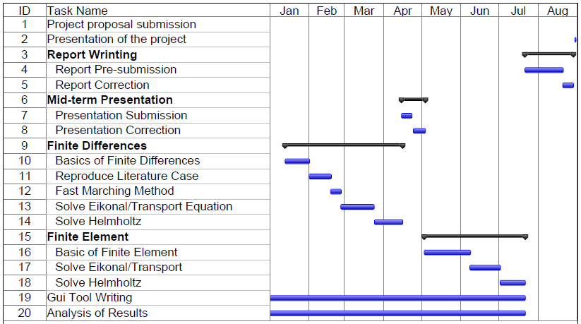

## Details

|  |  |
| --- | --- |
| Basics of Finite Differences | We want here to study the implementation of Finite Differences (FD) and reproduce published cases for well-known version of PDE or even some basic ODE. The purpose is to exercise various derivations and their representation in terms of finite differences including boundary/initial conditions. The goal is to understand how this approximation influences the solution. The underlying mathematics involves solving a linear algebraic system of the type $Ax = b$, but with a large matrix $A$, depending on the resolution of the grid. Usually $A$ is sparse, i.e. most of the matrix elements are zeros, the matrix being diagonal or tri-diagonal for example. |
| Reproduce Literature Case | There are existing publications, for example [9], that solve the Helmholtz equation (15) or (16) with a FD scheme. However, in [9] the coefficient $k$ in ($∇^{2}u+k^{2}u=0$) is a constant (usually $k=ω/c$), which is not our case. We hope that the method is adaptable to our situation. |
| Solve Helmholtz | In relation with what was said above, the task is here to adapt the solution of the above publications to our problem. |
| Fast Marching Method | The Eikonal equation (12) that is derived from the Helmholtz equation once the approximation (12) is made, may be solved by the Fast-Marching Method [10]. For this step the routine is already coded and available, but needs to be adapted to our current problem. In any case, it should be sufficiently understood in order to be integrated into our main task. |
| Solve Eikonal/Transport Equation | Solving the Eikonal equation (12) provides us with an input to the Transport equation (11) thereby providing the solution for the full problem of i.e. the amplitude and travel time of equation (9) . |
| Analysis of the results | We distribute this phase along the entire project, as it is always necessity to understand in each step the meanings of the results, and identify the errors we involved in these results. The analysis should verify if progress has been achieved as compared to other attempts to solve the problem and whether one needs to think about other ways or of modifications to a given simulation. |
| GUI Toole | We propose to build and use the GUI tool for demonstrating the computation and the results. Such a requirement implies that it would be necessary to modify it along the way, as we understand more clearly and precisely what demonstrations are useful and what are the relevant parameters, output, and graphical representation of a simulation. |
| Finite Elements | The same process may be followed by using the Finite Elements (FE) technique instead of the FD method described above - the principles would remain very similar. |

# Approval

Advisor signature: Date:

1. [http://www.sdms.org](http://www.sdms.org/public/soundmedicine.asp), Society of Diagnostic Medical Sonography.
2. Detection and characterization of breast masses with ultrasound tomography – Clinical results" - Duric et al – 2009.